Math Attachment Week # 3
Game of The Week: “THE ELIMINATORS”
Play a Game of Eliminator with someone at home. Help Find the Mystery Number…
- Decide who will be the Boss (the person to read the clues)
- Decide who will be the secret agent (the person who eliminates/crosses out the numbers described)
- Write the numbers 1-100 in a 10 x 10 box.
- Have the boss read these Mission orders to the secret agent.

Mission #1 The Boss Orders:
- Eliminate all numbers that have the digit 7 in them.
- Eliminate all the numbers that have the digit 3 in them.
- Eliminate all the even numbers except 100
- Eliminate all the numbers that have two digits that are the same (Note to Boss: this includes 100)
- Eliminate all the numbers that end in 0 or 5.
- Of all the numbers that remain, eliminate the first 6 numbers in the chart.
- Eliminate the odd numbers greater than 50 but less than 100.
- Circle the Mystery (target) number.
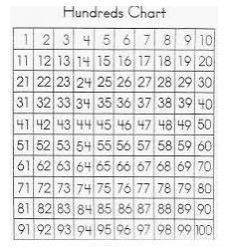

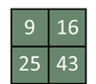
Journal Entry
Which one does not belong?
Look at the four images in the picture and explain WHY YOU THINK one does not belong. I am not looking for ONE right answer, there are many right answers. I am looking for the one that you think is correct.

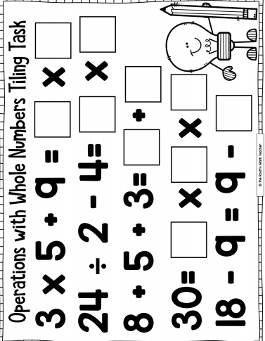
Operations Practice: Fill in the blanks with number to make each side of the equation EQUAL (use a calculator to check your work)

Problem of the Week: Solve the Picture Riddle
- Find the value of each piece of fruit
- Find the sum of the banana + grape

